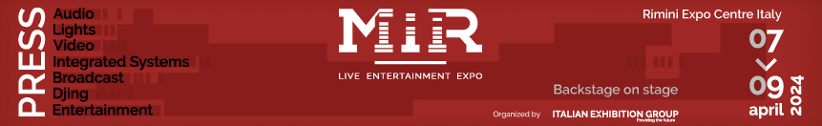

press release
(English translation)

MIR: A “GLITTERING” SEVENTH EDITION HAS COME TO A CLOSE IN RIMINI (ITALY)

- 20% increase in visitors and 25% increase in exhibitors at the Italian Exhibition Group event
- Ample space for the various aspects of the Light Design industry
- Great appreciation for the new MIR Club format

Rimini, 9th April 2024 - The 7th edition of MIR - Live Entertainment Expo, organised by Italian Exhibition Group, drew to a close today. A "glittering" edition under the banner of success that, at Rimini Expo Centre, Italy’s undisputed home of leisure and entertainment, focused on technology and innovation. The event registered an exceptional turnout, far exceeding the figures of the previous editions, including those held prior to the pandemic, notching up + 20% in visitors and + 25% in exhibitors.
With six pavilions and an extension to the Expo Centre’s SOUTH Hall, MIR responded specifically to the needs of companies and an increasingly attentive and qualified public.

Growth and Innovation
The event confirmed its leading position in the sector by attracting the most important and interesting technological innovations in the fields of audio, video, lighting for concerts, shows, education, retail, museums, IT and hospitality, with an additional exclusive showcase dedicated to System Integration AVC, thanks also to the consolidated collaboration with SIEC - Systems Integration Experience Community. In fact, the organisers' recent decision to also include technology brands aimed not only at business areas involved in the world of entertainment, but also to business and academic contexts with cutting-edge multimedia solutions, contributed to this result. An outstanding event in terms of professionalism, clarity and depth of the topics covered was the Light Design event, which saw numerous sessions devoted to the various aspects of this industry.

“Live You Play”: all sold out
In the halls dedicated to “Live You Play”, the frequency of performances exceeded all expectations, with audio, video and light solutions presented through real live shows. At this edition, the Immersive Rooms became a distinctive feature of the MIR event: their 13 daily sessions were all totally sold out.

MIR Club: a unique experience with 700 hours of pure scratch
But the highlight of the event was the MIR Club, which hosted an unprecedented format. With more than 30 DJ consoles installed, hundreds of people were able to test the products with the help of over 10 tutors for a total of over 700 hours of pure scratch. For the first time, Short clinics, held by young DJ Youtuber Federico Doria, also took place at the show, enabling visitors to deepen and broaden their knowledge of DJ technology. The Demolition panel, a unique opportunity for new talents to rub shoulders with the greatest DJs in Italian history, such as Albertino, Joe T Vannelli, Big Fish, Ale Lippi and others, was also a success in the name of pure fun.

MIR – Live Entertainment Expo has proven to be an unmissable event in the live entertainment industry, offering a unique discovery, networking and growth opportunity for professionals and fans alike. The next edition is scheduled for spring 2025.

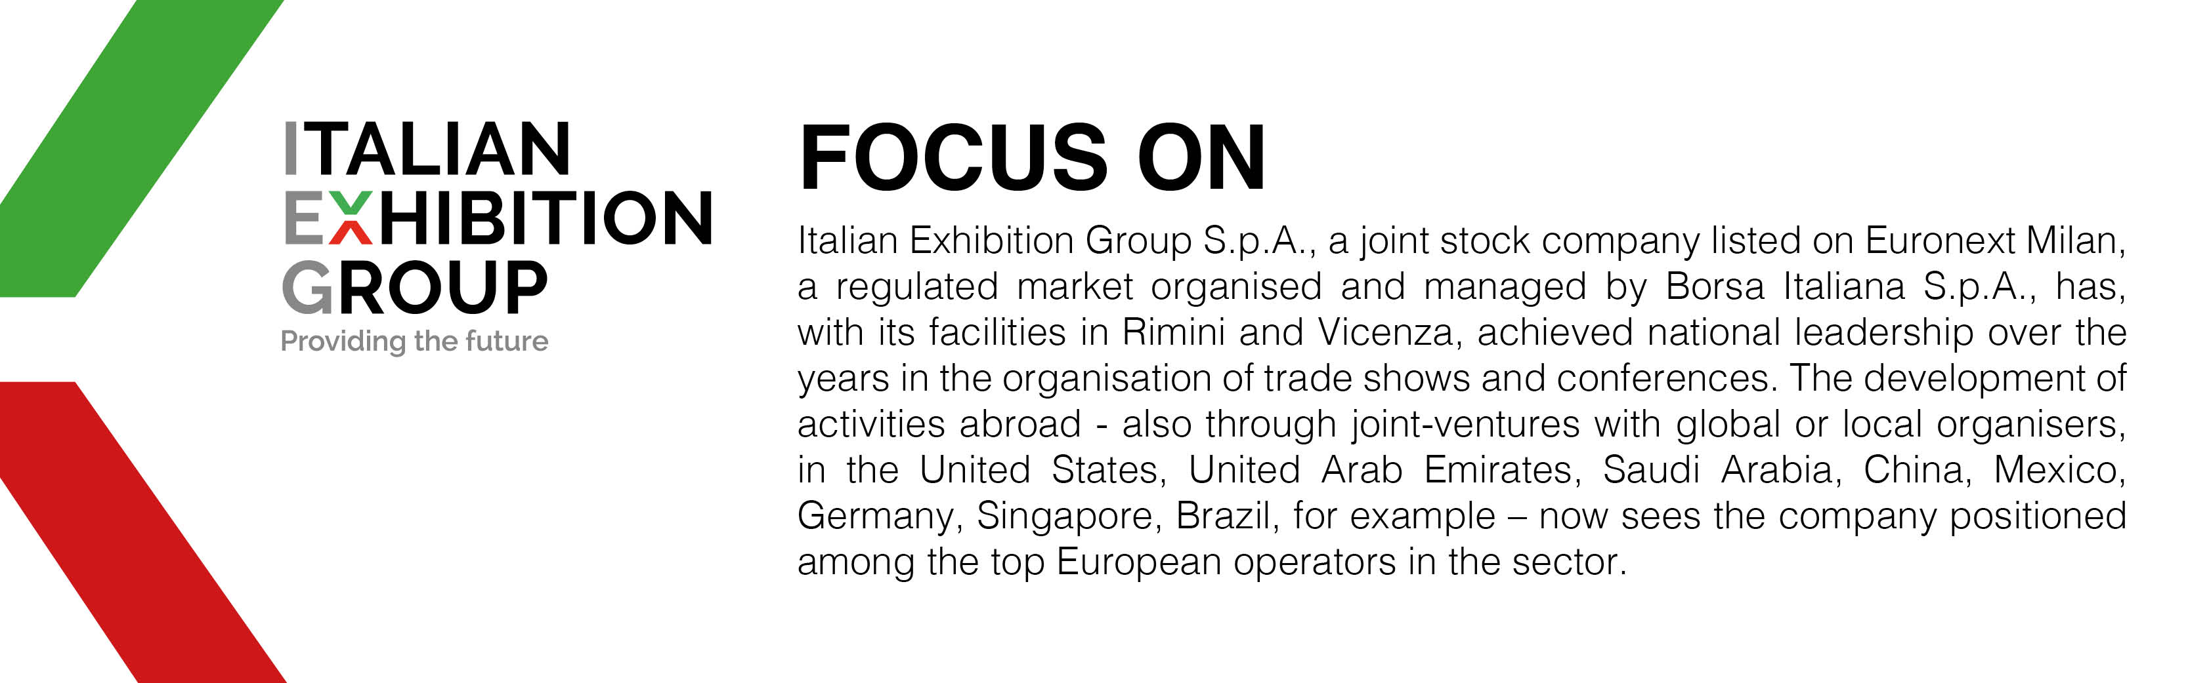

ABOUT MIR 2024
Organizer: Italian Exhibition Group S.p.A.; Recurrence: annual; Edition: 7th; Open to: professional operators and the general public; website: www.mirtechexpo.com

ITALIAN EXHIBITION GROUP PRESS CONTACTS
head of media relations & corporate communication: Elisabetta Vitali; press office manager: Marco Forcellini; press office specialist: Luca Paganin; international press office coordinator: Silvia Giorgi;

MEDIA AGENCY MIR
Naper Multimedia| Zoe Perna | T. +39 02 97699600 | email: staff@napermultimedia.it

This press release contains forecast elements and estimates that reflect the management’s current opinions (“forward-looking statements”), particularly regarding future management performance, realization of investments, cash flow trends and the evolution of the financial structure. For their very nature, forward-looking statements have a component of risk and uncertainty, as they depend on the occurrence of future events. The effective results may differ (even significantly) from those announced, due to numerous factors, including, only by way of example: food service market and tourist flow trends in Italy, gold and jewellery market trends, green economy market trends; the evolution of raw material prices; general macroeconomic conditions; geopolitical factors and evolutions in the legislative framework. Moreover, the information contained in this release does not claim to be complete, and has not been verified by independent third parties. Forecasts, estimates and objectives contained herein are based on the information available to the Company as at the date of this release.

